**ATANAS KAMBITOV COMPELTED COURSES**

Completed Udemy Courses:

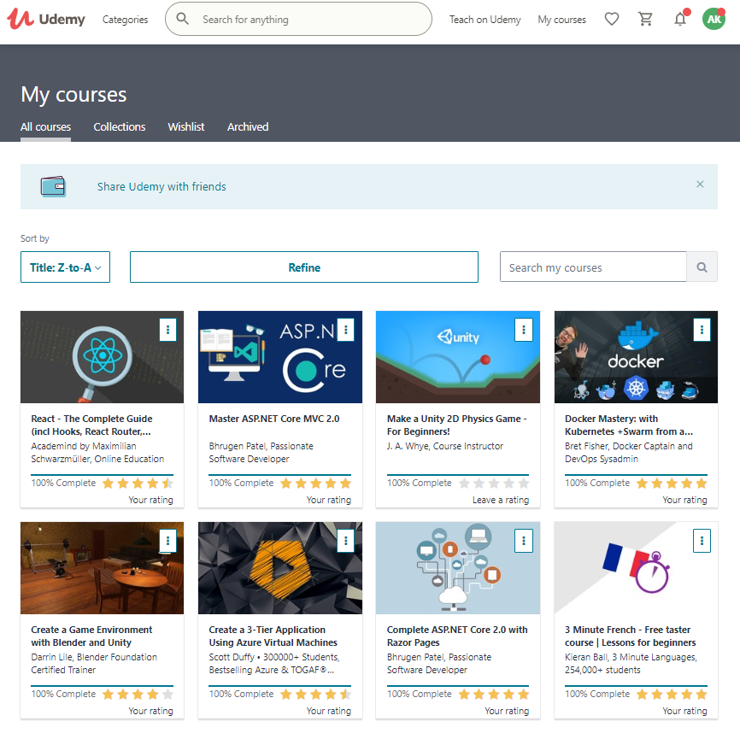

Completed Pluralsight Courses

